Children in Worship

Below are some ways that might help you and your children feel more comfortable in the worship service:
- Feel free to quietly explain to your child what is happening in the service. You’re welcome to help them find the right page in the hymnal, find the scripture passage in the Bible, or even encourage them to say a simple prayer during prayer time (even simple prayers are important).
- Know that children will model those around them. Encourage them to stand when you stand, sing when you sing, pray when you pray, and listen when you listen. They will learn by doing, and feel more and more like they belong as they learn what happens during a worship service.
- Please know that children of all ages are welcome to come forward for the “Children’s Moment,” the blessing/benediction at the end of the service, and when we have Holy Communion. We do use grape juice instead of wine so that all are able to participate.
- Don’t forget that activity bags, as well as children’s bulletins, are available for each child. If you’d like an activity bag during the service, they are available at the entrance to the sanctuary. Children’s Bulletins are handed out during the “Children’s Moment.”
- If you and/or your children need to leave the sanctuary during the service for any reason (to go to the bathroom, get a drink of water, etc.), please know that you’re welcome to do so. We just hope you’ll come back when you’re done. Everyone has needs, and we know that.
- Remember that everyone is welcome here. We hope that you and your children feel at home here. We are glad that you’ve joined us for church. We hope you’ll come back next week, too!

Your Family
Your Church

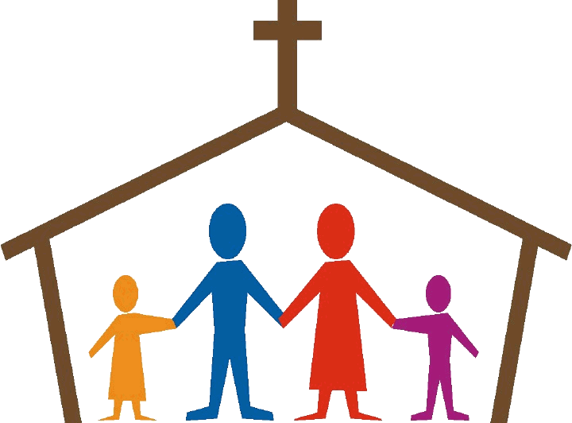

A Simple Guide for Worshiping as a Family
Laingsburg United Methodist Church
210 Crum St.
Laingsburg, MI 48848

Your Family is Welcome
Your family is welcome here! We strongly believe that church – all of it - is for families of all sizes and makeups. Church can be a family experience for you and your loved ones in every way you want for it to be. What, exactly, does that mean?
It means that…
- …We welcome children and youth of all ages to join us during our Sunday worship service. They are as much a part of our church as anyone else, and so, the worship experience is for them, too.
- …We invite families to sit together wherever they are comfortable and to participate in the worship service in whatever ways they’d like to.
- …We will go out of our way to
make sure that your whole
family can participate in the
ministries of this church, even
if that means we need to get
a bit creative.
- …We want to meet you where
you are in your life and where you are along your Christian journey (even if you’re just getting started). We look forward to get to know you and welcome you, just as you are. You and your family are important to us and to God.

This is a Place for Children & Youth
In addition to welcoming you as a family, we believe it is especially important that all children and youth feel as though they belong and are valued. Here are some of the ways we do this:

- We joyfully acknowledge that God has designed each child differently with different talents, abilities, and learning styles. We want to meet your children where they are and help them feel comfortable and as though they belong here (because they do!)
- We believe that God designed all children with the wiggles, giggles, and curious minds. These things are okay and welcome! It is important that they experience worship and all of church in ways that make them feel like themselves. The back of this folder provides some helpful ways for you to help them through the service.
- We work hard to include children in the worship experience. Our goal is to do this in ways that help them grow and learn, all while reminding them that they are important!
